F-LANE finalists September 2017
What is Sou Sou
Sou Sou is a mobile investment platform that partners with financial institutions and angel investors to decrease the time, cost and risk associated with lending to startups and early stage companies.
Mission
Sou Sou’s Mission is to close the access to capital gap that is crippling women globally by connecting investors and banks to high performing women borrowers that meet their lending criteria.
Background
Fonta Gilliam, Co-Founder of Sou Sou, worked as an American Diplomat in Africa where she spent countless hours helping women pitch to banks and investors for business loans. They were consistently overlooked by existing financial institutions yet still managed to finance their businesses through village and communal ; a system called “Sou Sou” in West Africa . Millions of people throughout the world have been using this strategy long before banks or private equity emerged as an alternative financing solution, thus bringing Gilliam to the idea of modernizing this ancient practice through technology, which has now become “Sou Sou”,- the crowdbanking platform.
Social impact
Sou Sou is the only lending marketplace designed to meet the unique needs of women entrepreneurs and women investors.
www.investsousou.com
Founder names
Fonta Gilliam | Innocnet Ephraim
From: Washington DC, United States of America

What is Gapsquare?
Gapsquare provides tools through technology that enable gender analysis within companies to develop plans for managing diversity and to narrow the gender gap.
This means for example providing instant visual insights into a company’s gender pay gap,
using HR and payroll data.
Mission
The aim is to expand into Europe and America in 2018 and into Australia in 2019.
The dream is a world where women are paid the same as men for doing the same work. Gapsquare’s mission is to help organisations make sense of their gender pay gap data.
Background
Zara Nanu, CEO started the company in 2015. Zara is a women’s rights activist with some hands-on experience in regards to gender inequality.
Women having to take care of children can end up in having a negative impact on their career progression, also known as the “motherhood penalty”. In the UK, women on average do not earn as much as their male counterparts. This is due to the gender pay gap, and it’s frequently due to occupational segregation, a lack of women in higher paid jobs.
Companies outperform their sector averages when they have a broad gender diversity. This is why it is so important to have insight into a company’s gender pay gap, thus having an easy tool to provide the insight.
Impact
The World Economic Forum stated that it will take 117 years for the gender pay gap to close. By using technology and available organisational data, one could skip at least a century of this inequality.
The long-term impact is to encourage companies to actively narrow their pay gap, so that the next generation does not have to experience the same issues currently faced in the workspace.
https://www.gapsquare.com/template/whatwedo
Founder names
Zara Nanu I Ion Suruceanu
From: Bristol, United Kingdom

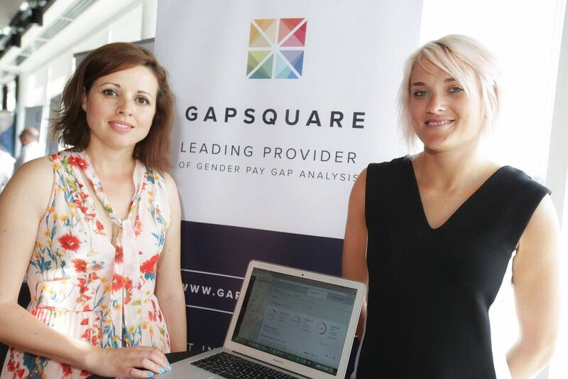

What is Kaaro Health?
Kaaro runs a telemedicine hub that provides a network of rural clinics with access to the services of qualified maternal and child health specialists. Health facilities located in rural areas that cannot afford enough specialized staff can make use of Kaaro’s "telemedicine-as-a-service" instead. This allows clinics, in exchange for a small fee, to interact with physicians and specialists stationed at Kaaro’s central hub. This fee is just a fraction of the cost required to hire a similarly qualified staff member. Rural clinics can access medical consultation, diagnosis, prescription, as well as referral services for pregnant and nursing mothers and their children under five.
Nurses who operate at the rural clinics can receive mentoring and medical education through the hub. The Hub services are accessed on-demand and are billed on a pay-as-you-go basis.
Mission
Kaaro Healths aim is to provide high quality care for mothers and infants in rural areas of Ibanda, Kotido, and Kabale.
These are areas where more than 77% of the clinics do not have a qualified staff.
Background
Kaaro Health initially started as a medical equipment leasing company, mainly financing energy-efficient portable ultrasound machines to rural clinics.
After relocating to a rural part of Ibanda , Angella Kyomugisha co-founder of Kaaro Health,
lost her baby due to an actually easily manageable complication where if she had had access to a qualified maternal specialist to assist the nurse the baby could have been saved.
This experience formed her passion for preventing maternal and infant mortality and this is how the idea of Kaaro Health came to be.
Impact
Many of the birth attendants or community health workers in these rural areas are unqualified with no formal training to handle women who need to deliver by Caesarean section or otherwise need advanced care. By providing these clinics with real-time access to qualified specialists, Kaaro Health is making a contribution in reducing maternal mortality.
www.kaarohealth.com
Founder names:
Angella Kyomugisha; Brenda Nantongo; Joyce Nakawungu; Francis Xavier Asiimwe
From: Ibanda, Uganda
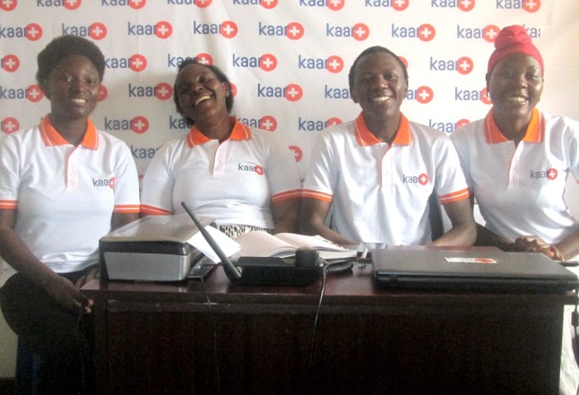

Sydney, Australia
Good on You
Good On You is a mobile app that delivers ethical brand ratings to millions of consumers around the globe, who want to make more ethical choices.
Through this mobile shopping app, Good On You connects retailers to conscious consumers, thus making it easy for people to shop according to their values.
Many of the clothes we buy cost the world’s poorest people and the environment a high price. There are shoppers who want to make ethical choices and buy cruelty free fashion, however it’s hard to know how a brand treats its workers, the planet and animals. This is where Good On You comes into play, by offering you information and ratings on brands and their social responsibilities, you are therefore able to make conscious choices.
Mission
Good On You’s mission is to change the face of the fashion industry to be more sustainable and fair. The plan is to have empowered 5 million users to shop ethically by 2020.This will create a more sustainable and fair future, especially for women and children.
Background
Co-founder Sandra Capponi spent many years working in the corporate sector, trying push the social responsibility of businesses from within. She then became aware of the responsibility she carried as an individual, and of the power that each individual has to change things through everyday choices we make.
Sandra has always been passionate about fashion, but what goes on behind the scenes of major labels raised her concern about the clothes she was wearing and under what circumstances they had been produced. The 2013 Rana Plaza collapse in Bangladesh which killed over 1000 garment factory workers, most of them were women, is what spiked Sandra’s awareness for clothing production and social responsibility.
Co-founder Gordon had already been playing with the idea of empowering people to shop more ethically when he and Sandra met and this is how Good On You was born.
Impact
Approximately 80% of garment workers are women, who receive low wages, despite unsafe and inhumane working conditions. Good On You allows shoppers to have a direct impact by actively being able to avoid labels that produce clothes under harmful and unethical conditions and instead support brands that empower people through their supply chains.
Your choice is your impact.
https://goodonyou.eco/about/
Founder names
Sandra Capponi; Gordon Renouf
From: Sydney, Australia
Motivation: Ethical and sustainable shopping
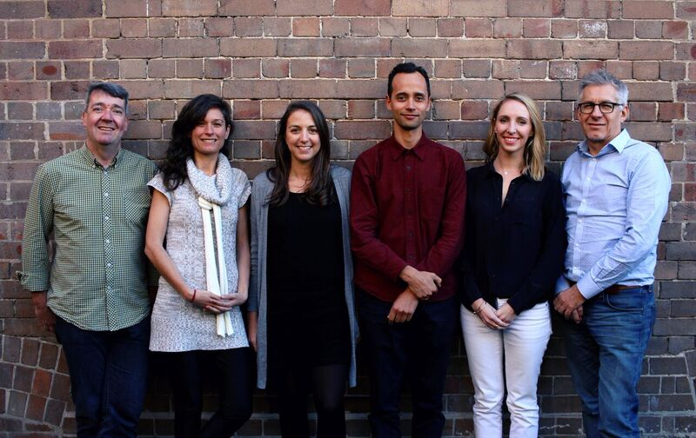

Mowoza
Mowoza strengthens Women Owned Micro and Small Retailers in Mozambican informal markets by integrating these MSEs into ‘digital retail communities’.
By applying smart, cutting edge technologies, to the informal retail sector they change marketplaces and retail in Mozambique and eventually in Africa. Private Blockchain solutions fit the transactional distributed processes in the sector. They each individually place orders, transact and request deliveries independently of their peers
Mission
In 8-10 years time they would like to impact at least 10 million micro and small business women retailers.
Background
In 2008 Suzana Moreira travelled across the border from the Spanish enclave of Ceuta into Morocco where she witnessed women, who are commonly referred to as “female mules“, carrying cargo weighing 80kgs or more on their back. This cargo comprised mostly of everyday essential products, like tinned food. Seeing the agony written all over the faces of elderly women as their knees gave way due to the weight on their backs is what motivated Suzana to look for solutions to empower micro and small women traders in Africa, and so the idea of Mowoza was born.
Impact
Helping micro and small business women retailers will lead to gender equality, economic growth, increased labour opportunities, responsible consumption and production. Mowoza is empowering women in growing businesses, accessing capital, generating employment and creating economic opportunities for their communities.
Mowoza contributes by providing them with training in business, financial and digital skills. This increases their understanding of key business, digital and financial concepts.
http://www.mowoza.com/
Founder name:
Suzana Moreira
From: Maputo, Mozambique

